A project report on
ENHANCED AUTONOMOUS ROBOT WITH CENTRAL NAVIGATION SYSTEM
Submitted in the partial fulfillment of the requirements for the award of the degree of
BACHELOR OF TECHNOLOGY
IN
ELECTRICAL AND ELECTRONICS ENGINEERING
SUBMITTED BY
T. Neelima 18MH1A0204
B.Manikanta 19MH5A0206
B.Venkataswamy 19MH5A0207
Ch. Surya Vamsi 19MH5A0213
G.Durga Surya Vamsi 19MH5A0218
Under the esteemed guidance of
K. Manoz Kumar Reddy (Ph.D)
Assistance Professor


ADITYA COLLEGE OF ENGINEERING

Department of Electrical and Electronics Engineering

Approved by AICTE, Permanently Affiliated to JNTUK & Accredited by NAAC Recognized by UGC under Sections 2(f) and 12(B) of UGC Act, 1956 Aditya Nagar, ADB Road, Surampalem – 533 437.
CERTIFICATE
ADITYA COLLEGE OF ENGINEERING
Department of Electrical and Electronics Engineering
Approved by AICTE, Permanently Affiliated to JNTUK & Accredited by NAAC Recognized by UGC under Sections 2(f) and 12(B) of UGC Act, 1956 Aditya Nagar, ADBRoad,


SURAMPALEM – 533 437.

This is to certify that the project report entitled “ENHANCED AUTONOMOUS ROBOT WITH CENTRAL NAVIGATION SYSTEM” being submitted by.
T. Neelima 18MH1A0204
B.Manikanta 19MH5A0206
B.Venkataswamy 19MH5A0207
Ch. Surya Vamsi 19MH5A0213
G.Durga Surya Vamsi 19MH5A0218

In the partial fulfillment of the requirement for the award of the degree of the Bachelor of Technology in Electrical and Electronics Engineering from Aditya college of engineering. It is the record of bonafide work, carried out by them at Aditya College of Engineering.

Project Guide Head of the Department
Sri. K.Manoz Kumarreddy,(Ph.D.), M.Tech Sri. K.Manoz Kumarreddy,(Ph.D.) M.Tech
Assistance Professor Assistance Professor

ACKNOWLEDGEMENT
The satisfaction that accompanies the successful completion of any task would be incomplete without the mention of the people who made it possible and whose constant guidance and encouragement crown all the efforts with success. The acknowledgment transcends the reality of formality.
We are thankful to our beloved guide cum Head of the Department Sri. K. M. K. REDDY, M.Tech(Ph.D),, M.Tech, Assistant Professor who has spared his valuable time and append novel ideas to guide me in limelight. I am indebted to him without whom I may not have culminated in the pinnacle of the project.
We are thankful to Dr.A.RAMESH, M.Tech, Ph.D., Principal, Aditya College of Engineering for providing the appropriate environmental required for this project.
We also thankful to all staff members, lab technicians, librarians and friends who are directly and indirectly helped me in the completion of the project with flying colors.

With sincere regards
T. Neelima 18MH1A0204
B.Manikanta 19MH5A0206
B.Venkataswamy 19MH5A0207
Ch. Surya Vamsi 19MH5A0213
G.Durga Surya Vamsi 19MH5A0218

DECLARATION

We hereby declare that this project titled “ENHANCED AUTONOMOUS ROBOT WITH CENTRAL NAVIGATION SYSTEM” has been undertaken and this work is submitted to ADITYA COLLEGE OF ENGINEERING, Surampalem, affiliated to JAWAHARLAL NEHRU TECHNOLOGICAL UNIVERSITY, Kakinada in the partial fulfillment of the Degree of Master of Technology.

We further declare that this project work has not been submitted in full or part for the award of any other degree in this or any other Educational institutions

T. Neelima 18MH1A0204
B.Manikanta 19MH5A0206
B.Venkataswamy 19MH5A0207
Ch. Surya Vamsi 19MH5A0213
G.Durga Surya Vamsi 19MH5A0218

ABSTRACT

Many tasks which are beyond human ability can be performed with the help of robotics. In this project, autonomous robots with a central navigation system are used to deliver packages from source to destination.
The navigation of tracking the robot using Arduino is used to deliver the objects from source to destination quickly within an effective manner with accuracy without using the sensors. The camera is continuously monitoring the robot and assigns the path based on the software instructions.
In this project, we have used a python script with an open cv to track the robot with color and used mathematics formulas to triangulate the color boxes on the robot to find the position and orientation of the robot. Thereafter we have used the python requests module to send the respective commands to navigate the robot from the pc. A single-camera has been used to track two robots. The pc will send the commands to Robot through wifi.
Autonomous robots can be used to improve the speed and accuracy of routine operations, particularly in warehousing and manufacturing spaces; work side-by-side with humans for added efficiency, and reduce the risk of employee injury in dangerous environments.
Robots are useful in many ways. For instance, it boosts the economy because businesses need to be efficient to keep up with the industry competition. Therefore, having robots helps business owners to be competitive, because robots can do jobs better and faster than humans can, e.g. robots can be built, and assemble a car.
Keywords : Arduino uno Wi-Fi rev 2, DC motors, webcam, Servo motor, Battery.

CONTENT
Chapters Page number
1. INTRODUCTION 9
2. LITERATURE SURVEY 10
3. MAJOR COMPONENTS DESCRIPTION 11
3.1 ARDUINO UNO Wi-Fi REV 2 11 - 12
3.1.1 DETAILS 12 - 13
3.1.2 Use your Arduino Uno WiFi Rev2 on the Arduino
Web IDE 14
3.1.3 USE OF ARDUINO UNO WIFI SHIELD 14
3.1.4 ARDUINO IDE 14 - 15
3.2 SERVO MOTOR 15 – 16
3.2.1 SERVO MOTOR THEORY 16
3.2.2 SERVO MOTOR WORKING MECHANISM 17
3.2.3 SERVO MOTOR WORKING PRINCIPLE 17 - 18
3.2.4 INTERFACING OF SERVO MOTOR WITH
MICROCONTROLLER 18

LIST OF FIGURES

FIGURES PAGE NUMBERS
3.1 Arduino Uno WI-Fi Rev 2 Board 11
3.2 Servo Motor 16
3.2 Servo Motor

LIST OF TABLES
TABLES PAGE NUMBER
3.1.1 Specifications 12
3.1.2 Details Of Arduino Uno Wi-Fi Rev2 Board 13

CHAPTER 1
INTRODUCTION
An autonomous robot is a robot that is designed and engineered to deal with its environment on its own, and work for extended periods of time without human intervention. Autonomous robots often have sophisticated features that can help them to understand their physical environment and automate parts of their maintenance and direction that used to be done by human hands. Autonomous robots typically go about their work without any human interaction unless that human interaction is necessary as part of their task.
Autonomous robots are intelligent machines capable of performing tasks in the world by themselves, without explicit human control. Examples range from autonomous helicopters to Roomba, the robot vacuum cleaner.

Many tasks which are beyond human ability can be performed with the help of robotics and robotics in the war will be very helpful in its operation.

The advancement of robot technology will be amazing and today, robots can be seen virtually in all the fields from transport to health, and recreation to industries.

The use of this technology will get proclamations from society for taking away the jobs of an ordinary man.

But to solve the issues related to this the usage of robots should be applied to selected tasks and mostly be used in the areas where a human cannot reach or is not capable of performing.

CHAPTER 2
LITERATURE SURVEY
Autonomous vehicle technologies are receiving great attention with increasing demands for autonomy for both civilian and military purposes. In addition, advanced perception techniques and the capability to locate obstacles and targets are necessary to properly operate autonomous systems. Moreover, achieve reliable levels of performance by determining the faults and enabling the system to operate with these faults in mind. Fault tolerance is required to analysing the measured input/output signals of the system.
Autonomous vehicles have become increasingly important assets in various civilian and military operations due to their capability for automatic navigation. These vehicles are able to operate and react to their environment without any outside controls. Autonomous vehicles offer numerous key advantages within the modern world. They can function during the daytime and at night when risky missions are involved (compared with manned ground vehicles). In the last decade, significant innovations have taken place in the field of autonomous vehicles and for unmanned ground vehicles (UGVs) in particular. Autonomous vehicle navigation is especially difficult due to several obstacles including bad weather.
Vision-based autonomous navigation has mostly been enhanced for autonomous-based ground vehicles. The use of vision is very essential in solving problems involving autonomous navigation and localization.

CHAPTER 3
Major Components Description In This Project

3.1 ARDUINO UNO WI-FI REV 2 BOARD
The Arduino UNO WiFi Rev 2 is the easiest point of entry to basic IoT with the standard form factor of the UNO family. Whether you are looking at building a sensor network connected to your office or home router, or if you want to create a Bluetooth Low Energy device sending data to a cellphone, the Arduino UNO WiFi Rev 2 is your one-stop-solution for many of the basic IoT application scenarios.
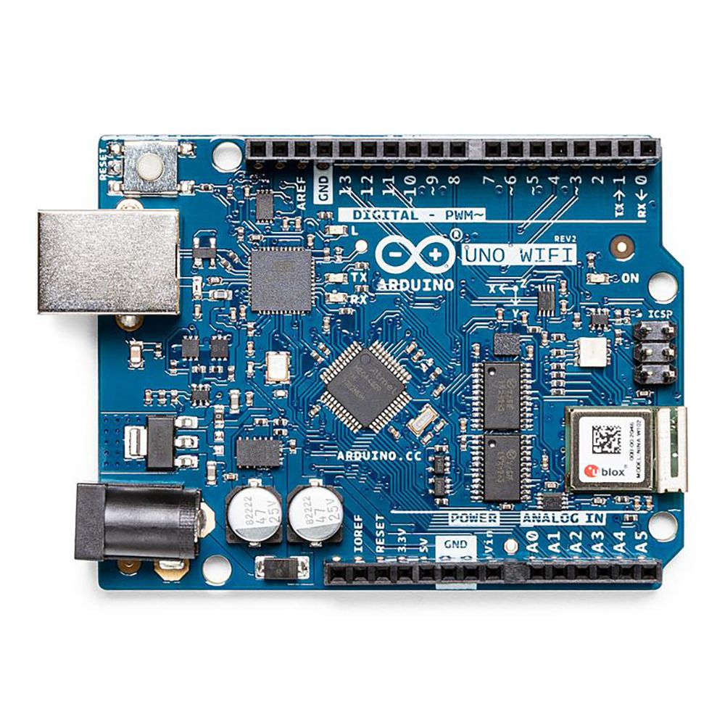
Fig 3.1 : Arduino Uno Wi-Fi Rev 2 Board
Add this board to a device and you'll be able to connect it to a WiFi network, using its secure ECC608 crypto chip accelerator. The Arduino Uno WiFi is functionally the same as the Arduino Uno Rev3, but with the addition of WiFi / Bluetooth and some other enhancements. It incorporates the brand new ATmega4809 8-bit microcontroller from Microchip and has an onboard IMU (Inertial Measurement Unit) LSM6DS3TR.
The Wi-Fi Module is a self-contained SoC with an integrated TCP/IP protocol stack that can provide access to a Wi-Fi network, or act as an access point. Whether you are looking at building a sensor network connected to your office or home router, or if you want to create a BLE device sending data to a cellphone, the Arduino UNO WiFi Rev.2 is your one-stop-solution for many of the basic IoT application scenarios.
The Arduino UNO WiFi Rev 2 has 14 digital input/output pins—5 can be used as PWM outputs—6 analog inputs, a USB connection, a power jack, an ICSP header, and a reset button. It contains everything needed to support the microcontroller. Simply connect it to a computer with a USB cable or power it with an AC adapter or battery to get started.

3.1.1 Details
Add this board to a device and you'll be able to connect it to a WiFi network, using its secure ECC608 crypto chip accelerator. The Arduino Uno WiFi is functionally the same as the Arduino Uno Rev3, but with the addition of WiFi / Bluetooth and some other enhancements. It incorporates the brand new ATmega4809 8-bit microcontroller from Microchip and has an onboard IMU (Inertial Measurement Unit) LSM6DS3TR.
The Wi-Fi Module is a self-contained SoC with an integrated TCP/IP protocol stack that can provide access to a Wi-Fi network, or act as an access point.
The Arduino UNO WiFi Rev.2 has 14 digital input/output pins—5 that can be used as PWM outputs—6 analog inputs, a USB connection, a power jack, an ICSP header, and a reset button. It contains everything needed to support the microcontroller. Simply connect it to a computer with a USB cable or power it with an AC adapter or battery to get started.

3.1.1 Specifications
Attribute | Value
Product Name | UNO WiFi Rev 2
Processor Part Number | ATmega4809
Revision | V2

3.1.2 Details Of Arduino Uno Wi-Fi Rev2 Board
Operating Voltage | 5 V
Input Voltage | 7 V - 12 V
Digital I/O | 14
Analog Input Pins | 6
DC Current For 3.3V Pin | 50 mA
SRAM | 6.144 Bytes
Clock Speed | 16 MHz
Secure Element | ATECC608A
LED_Builtin | 25
Width | 53.3 mm
Analog Input Pins | 6
DC Current per I/O Pin | 20 mA
Flash Memory | 48 KB
EEPROM | 256 Bytes
Radio Module | u-blox NINA-W102
Inertial Measurement Unit | LSM6DS3TR
Length | 101.52 mm
Weight | 37 g

The Arduino Uno WiFi Rev2 is an Arduino Uno with an integrated WiFi module. The board is based on the Microchip MEGA4809 with an ESP32 u-blox NINA-W13 WiFi Module integrated. The NINA-W13 Module is a self-contained SoC with an integrated TCP/IP protocol stack that can give access to your WiFi network (or the device can act as an access point). The Arduino Uno WiFi Rev2 is programmed using the Arduino Software (IDE).

3.1.2 Use your Arduino Uno WiFi Rev2
With the Arduino WiFi Shield, this library allows an Arduino board to connect to the internet and to read and write an SD card using the SD library. It can serve as either a server accepting incoming connections or a client making outgoing ones. The library supports WEP and WPA2 Personal encryption, but not WPA2 Enterprise. The WiFI library is similar to the Ethernet library and many of the function calls are the same.
3.1.3 Use Of Arduino WiFi Shield
The Arduino WiFi shield allows an Arduino board to connect to the internet using the WiFi library and to read and write an SD card using the SD library.
The WiFi Library is included with the most recent version of the Arduino IDE. The firmware for the WiFi shield has changed in Arduino IDE 1.0.4.
The WiFi library is similar to the Ethernet library and many of the function calls are the same.
3.1.4 Arduino IDE
The Arduino integrated development environment (IDE) is a cross-platform application (for Windows, macOS, Linux) that is written in the programming language Java. It is used to write and upload programs to Arduino compatible boards, but also, with the help of 3rd party cores, other vendor development boards.
The source code for the IDE is released under the GNU General Public License, version 2. The Arduino IDE supports the languages C and C++ using special rules of code structuring. The Arduino IDE supplies a software library from the Wiring project, which provides many common input and output procedures. User-written code only requires two basic functions, for starting the sketch and the main program loop, that are compiled and linked with a program stub main() into an executable cyclic executive program with the GNU tool chain, also included with the IDE distribution. The Arduino IDE employs the program argued to convert the executable code into a text file in hexadecimal encoding that is loaded into the Arduino board by a loader program in the board's firmware.
Arduino is a prototype platform (open-source) based on an easy-to-use hardware and software. It consists of a circuit board, which can be programmed (referred to as a microcontroller) and a ready-made software called Arduino IDE (Integrated Development Environment), which is used to write and upload the computer code to the physical board.
Arduino provides a standard form factor that breaks the functions of the micro-controller into a more accessible package.
This tutorial is intended for enthusiastic students or hobbyists. With Arduino, one can get to know the basics of micro-controllers and sensors very quickly and can start building prototype with very little investment.
This tutorial is intended to make you comfortable in getting started with Arduino and its various functions.
Before you start proceeding with this tutorial, we assume that you are already familiar with the basics of C and C++. If you are not well aware of these concepts, then we will suggest you go through our short tutorials on C and C++. A basic understanding of microcontrollers and electronics is also expected.
3.2 Servo Motor
A servomotor is a linear actuator or rotary actuator that allows for precise control of linear or angular position, acceleration, and velocity.. It consists of a motor coupled to a sensor for position feedback. It also requires a servo drive to complete the system. The drive uses the feedback sensor to precisely control the rotary position of the motor. It also requires a relatively sophisticated controller, often a dedicated module designed specifically for use with servomotors.

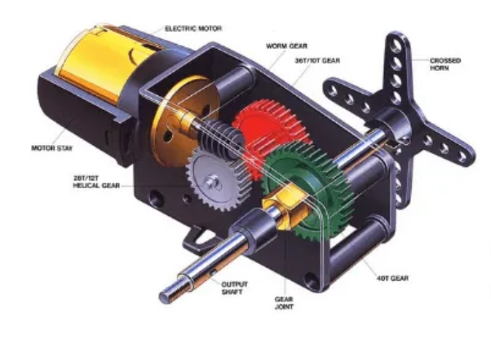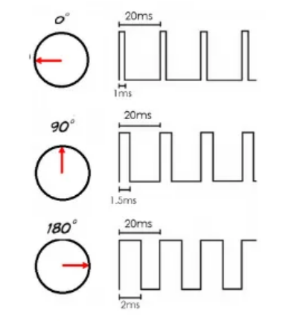
3.2 Servo Motor

3.2.1 Servo Motor Theory

There are some special types of applications of an electric motor where the rotation of the motor is required for just a certain angle. For these applications, we require some special types of motor with some special arrangement which makes the motor rotate a certain angle for a given electrical input (signal). For this purpose, servo motor comes into the picture.
The servo motor is usually a simple DC motor controlled for specific angular rotation with the help of additional servomechanism (a typical closed-loop feedback control system). Nowadays, servo systems are used widely in industrial applications.
Servo motor applications are also commonly seen in remote-controlled toy cars for controlling the direction of motion, and it is also very widely used as the motor which moves the tray of a CD or DVD player. Besides these, there are hundreds of servo motor applications we see in our daily life.
The main reason behind using a servo is that it provides angular precision, i.e. it will only rotate as much we want and then stop and wait for the next signal to take further action. The servo motor is unlike a standard electric motor which starts turning as when we apply power to it, and the rotation continues until we switch off the power. We cannot control the rotational progress of electrical motor, but we can only control the speed of rotation and can turn it ON and OFF. Small servo motors are included many beginner Arduino starter kits, as they are easy to operate as part of a small electronics projects.

3.2.2. Servo Motor Working Mechanism
It consists of three parts:
- Controlled device
- Output sensor
- Feedback system
It is a closed-loop system where it uses a positive feedback system to control motion and the final position of the shaft. Here the device is controlled by a feedback signal generated by comparing output signal and reference input signal.
Here reference input signal is compared to the reference output signal and the third signal is produced by the feedback system. And this third signal acts as an input signal to the control the device. This signal is present as long as the feedback signal is generated or there is a difference between the reference input signal and reference output signal. So the main task of servomechanism is to maintain the output of a system at the desired value at presence of noises.
3.2.3 Servo Motor Working Principle
A servo consists of a Motor (DC or AC), a potentiometer, gear assembly, and a controlling circuit. First of all, we use gear assembly to reduce RPM and to increase torque of the motor. Say at initial position of servo motor shaft, the position of the potentiometer knob is such that there is no electrical signal generated at the output port of the potentiometer. Now an electrical signal is given to another input terminal of the error detector amplifier. Now the difference between these two signals, one comes from the potentiometer and another comes from other sources, will be processed in a feedback mechanism and output will be provided in terms of error signal. This error signal acts as the input for motor and motor starts rotating. Now motor shaft is connected with the potentiometer and as the motor rotates so the potentiometer and it will generate a signal. So as the potentiometer’s angular position changes, its output feedback signal changes.

After sometime the position of potentiometer reaches at a position that the output of potentiometer is same as external signal provided. At this condition, there will be no output signal from the amplifier to the motor input as there is no difference between external applied signal and the signal generated at potentiometer, and in this situation motor stops rotating.

3.2.3 Interfacing of servo Motor With Microcontrollers

